**ACKNOWLEDGEMENT**

IMGT 3+34 – Design & Development of Computer based Project is of significant importance for me as an undergraduate and there are many stakeholders who contributes towards completion of this project to whom I must extend my sincere thanks.

I convey my special thanks to my first supervisor Mrs.M.G.S.Dilanthi for the invaluable supervision and guidance she affords me. I sincerely thank my second supervisor Ms.J.M.N.M.Jayasinghe for her continuous assistance in this regard.

My sincere gratitude is extended to Dr.A.D.Dharmawansa, for the great guidance offered by conducting the course modules which were of great support for the development of the system which is presented in this report.

I would also like to express my sincere gratitude to all the academic staff of the Department of Industrial Management, Faculty of applied Sciences of Wayamba University of Sri Lanka for their direct and indirect support toward the project.

I am highly gratitude to all the managers and non-managers in Trans-Merch Apparel (Pvt) Ltd for giving me the opportunity to analyze their existing system by providing valuable information with no hesitation whenever it was necessary.

I thank my colleagues and everyone who provided me with encouragement, support and guidance throughout this project.

**PREFACE**

This report is submitted in the partial fulfillment of the requirements for the Bachelor of Science (Joint Major/ Special) Degree Programme offered by the Department of Industrial Management of the Faculty of Applied Sciences of Wayamba University of Sri Lanka.

Through this report the functions of a Performance Evaluation System are identified. The study is based on an apparel manufacturing company, Trans-Merch Apperal (Pvt) Ltd, Kadawatha. The inefficiency and ineffectiveness of the existing system which is currently being operated manually is analysed and a system is proposed to eliminate the drawbacks and enhance the effectiveness.

This report includes an introduction of the organization, ER diagram and the graphical interface designs that I have created for the system. And further it contains normalized database structure and also the table previews and formats of reports that are going to be generated. This is a project report which provides an analysis of performance evaluation.

**CONTENTS**

1. INTRODUCTION 1

1.1 Introduction to the Organization 1

1.2 Introduction to the Existing System 1

1.2.1 Details of the System Boundary 2

1.3 Problems or Weakness of the Existing System 3

1.4 Aims and Objectives of the Project 3

1.5 Overview of the Chapters 3

2. SYSTEM ANALYSIS 5

2.1 Analysis of the Existing System 5

2.1.1 Natural Language Description with Semi Formal Graphical Software Process Models 5

2.1.6 Problem Definition 11

2.2 Software Solutions 12

2.2.1 Requirement Catalogue 12

2.2.2 Business System Options (BSOs) 13

2.2.3 Requirement Catalogue vs. BSOs 14

2.2.4 The Selected BSO and Justification 16

3. SYSTEM DESIGN 17

3.1 Natural Language Description with Semi Formal Graphical Software Process Models 17

3.1.2 Document Flow Diagram 18

3.1.3 Level 1 Data Flow Diagram 19

3.1.4 Level 2 Data Flow Diagram 20

3.2 Architectural Design 21

3.3 Data Base Design 23

3.3.1 Entity Model 23

3.3.2 Logical Data Structure 24

3.3.3 Entity Relationship Diagram 25

3.3.4 Relational Schema 26

3.4 Graphical User Interface Design 26

3.4.1 Login 27

3.4.2 Main Menu 27

3.4.3 User Registration 28

3.4.4 Edit Users 28

3.4.5 Change password 29

3.4.6 Add Details 30

3.4.7 Search Details 30

3.4.8 Efficiency 31

3.4.9 Defect Rate 31

3.4.10 Efficiency 32

3.4.11 Defect Rate 33

3.4.12 Set Teams 33

3.4.13 Attendance 34

3.4.14 Set Holidays 34

3.4.15 Best Employee 35

3.4.16 Overall Performance 36

3.5 Report Design 37

4.IMPLEMENTATION 41

4.1 Data Structures 41

4.2 Algorithms Used 41

4.2.1Calculating Efficiency 41

4.2.2 Calculating Defect Rate 41

4.2.3 Calculating Attendance 41

4.2.5.Calculating Overall Performance 43

4.2.5 Generate Reports 45

Chapter 5 - TESTING 47

5.1 Testing Methodology Used 47

5.2 Test Reports 47

5.5.1 Log in 48

5.5.2 Validation Errors 48

5.5.3 Messages for Report Generation 48

5.3 User Evaluation 49

5.3.1 Speed 49

5.3.2 Reduced Errors 49

5.3.3 User Friendliness 49

5.3.4 Help to Make Management Decisions 49

Chapter 6 - DISCUSSION AND CONCLUSION 50

6.1 Summery 50

6.2 Limitation of this System 50

6.3 Discussion and Recommendation for Further Works 51

6.4 Conclusion 51

**LIST OF TABLES**

Table 1: Table of Functional Requirements 13

Table 2 : Table of Non - Functional Requirements 14

Table 3 : Table of Functional Requirements vs. BSOs 15

Table 4 : Table of Non- functional Requirements vs. BSOs 16

**LIST OF FIGURES**

Figure 1 : Business Activity Model 8

Figure 2: Document Flow Diagram for Existing System 9

Figure 3 : Context Diagram for Existing System 10

Figure 4:Level 1 DFD for existing system 11

Figure 5:Level 2 DFD For existing system 12

Figure 6:Level 2 DFD For existing system 12

Figure 7:Level 2 DFD For existing system 13

Figure 8:Context diagram for proposed system 18

Figure 9: Document Flow diagram for proposed system 19

Figure 10:Level 1 DFD for proposed system 21

Figure 11:Level 2 DFD 22

Figure 12:Level 2 DFD 22

Figure 13:Level 2 DFD 23

Figure 14: Architectural Design 24

Figure 15:ER Diagram 27

Figure 16:Relational Schema 27

Figure 17:Log in 28

Figure 18:Main Menu 29

Figure 19:User Registration 29

Figure 20:Edit User 30

Figure 21:Change Password 30

Figure 22:add Personal Details 31

Figure 23: Add Details 31

Figure 24:Search personal details 31

Figure 25:Efficiency 32

Figure 26:Defect Rate 32

Figure 27:Efficiency 33

Figure 28:Defect Rate 34

Figure 29:Set teams 34

Figure 30:Attendance 35

Figure 31:Set Holidays 35

Figure 32:Best Employee 36

Figure 33:Search Performance 37

Figure 34:Overall Performance Report 38

Figure 35:Best Employee Report 38

Figure 36:Employee Efficiency Report 39

Figure 37:Employee Overall performance report 40

Figure 38: Message for wrong user name or password 48

Figure 39:Message for Validation Errors 48

Figure 40:Message for Report Generation 49

Figure 41: Message for Report Generation 49

# 1. INTRODUCTION

## 1.1 Introduction to the Organization

Trans-Merch Apparel Pvt Ltd was established in Toronto, Canada in 2006 as an apparel manufacturing and design company. They manufacture and distribute to all leading customers across North America. Furthermore they have strategic partnerships with Walmart, target, Sears and Bay Company. They own and operate manufacturing and distribution locations in Toronto, New York and Sri Lanka.

The Sri Lankan branch of Trans Merch Apparel pvt Ltd was established in Kadawatha in 2015.07.02. The current owner of the organization is Mr. Welayudan Ilangeshwaran Currently about 126 workers are working there under 3 managerial levels.

## 1.2 Introduction to the Existing System

Trans-Merch Apparel execute the following operations as a garment manufacturing company.

* Planning
* Cutting
* Production
* Packing
* Stores
* Finance
* Human resource management
* Mechanical operations

From the whole business process, performance evaluation of the factory workers of Trans-Merch Apparel Pvt Ltd, is selected for this project. That is under the Human Resource department of the company. Here factory workers in 3 departments including Cutting Department, Production Department and Finishing Department are considered. Some of the functions under performance evaluation are as follows.

* Recording attendance - An attendance sheet is given to the factory workers to sign daily and then it is sent to the HR department.
* Quality audit - Items are checked by the quality auditors to find the faults in them. Also they are maintaining quality levels in each process of the system
* Calculating efficiency of each worker-The efficiency is calculated according to the daily production or the daily work done by them.

I am willing to introduce a more user friendly and accurate computerized performance evaluation system to their organization. Also I hope to implement more accurate report generation procedure for the system to make it easier for usage.

### 1.2.1 Details of the System Boundary

Evaluate the performance of factory workers.

There are various types of factory workers in the company under different sections. They are,

* Cutting section - Cutting helper, Cutter, Cutting supervisor
* Production section - Machine operator, Helper
* Packing section - Packing helper, Ironer
* Stores - Store keeper, Store assistance, Store helper

The system boundary contains following things.

* + Employee attendance
  + Overtime payment
  + Cost per unit
  + Incentives based on performance
  + Number of units produced at a particular time period
  + Number of defective items produced at a particular time period
  + Quality of the products
  + Time taken to finish a given task
  + Cooperation among workers

## 1.3 Problems or Weakness of the Existing System

* The performance evaluation system is done some extent to manually at the moment
* The company has to keep separate files for enter some performance evaluation information
* Employees has no clear idea on what they can expect from the company
* Keeping document files requires some space
* Threat of losing and decay of originals of documents
* No tool to identify the weaknesses of the performance evaluation

## 1.4 Aims and Objectives of the Project

* Measure the performance
* Identify training needs of employees
* Increase efficiency
* Reduce paperwork
* Cut off cost
* Create a user friendly system for the organization
* Proper handling in all included activities
* Maintain more sincere relationship between the factory workers and managers
* Management of technology to obtain the maximum utilization of available resources
* Help the government mission of IT literacy enhancement

## 1.5 Overview of the Chapters

**Chapter 1** -Includes an introduction about the organization and about its existing system. Further, problems and weaknesses of the existing system have been identified. The chapter also discusses about the aims and objectives of this project. Finally the chapter concludes with an overview of coming chapters.

**Chapter 2** - Includes the analysis of the existing system. To describe the existing system in here uses graphical software called “Select Case Tool” under the concepts of “Structured System Analysis & Design Methodologies”. In this chapter it identifies different user requirements and business system options (BSOs). After that it identifies the particular business system option and gives a justification of that.

**Chapter 3** - Will cover the designing stage of the system. In here first describes the proposed system by using graphical software. Then it describes the architectural design of the system. Then it describes how the database tables are designed by using ER diagrams. Next it describes how graphical user interfaces and management support reports were developed under the user requirements.

**Chapter 4** - Includes the implementation stage of the system. It includes data structures and algorithms which are used to implement the system. Under that there are some functions for the insert and update inside the “if” statement. And also a function to automatically generate new number as ID for a particular section. In the meantime the system is capable enough to generate the bills and reports for the required functions.

**Chapter 5** - Will cover the testing stage of the system. It represented in several test reports. Among them are testing of user name and pass ward validation, Massage boxes appearing and the new ID generation for all sections.

**Chapter 6 -** Will include summarization of the overall project. It included limitations of the study, recommendations for the further works of the software and the conclusion.

# 2. SYSTEM ANALYSIS

## 2.1 Analysis of the Existing System

The current performance evaluation system is analyzed using the following tools.

### 2.1.1 Natural Language Description with Semi Formal Graphical Software Process Models

#### 2.1.1.1Business Activity Model

Business activity model represents all the business activities in the organization and how those activities are interconnected with each other, inside and outside the system boundary. The business activity model in figure 1 illustrates the business activities of the Trans-Merch Apparel (Pvt) Ltd.

Different types of activities are executed in the current performance evaluation system. After the targets are set the instructions are sent to relevant departments and the operations are begun. While those operations are going the work done by the factory worker is mainly observed by supervisors and the data is recorded. Then those data are sent to Human Resource Department to evaluate performance of the employees.



Figure 1 : Business Activity Model

#### 2.1.1.2 Document Flow Diagram

The document flow diagram illustrates how the physical documents passed within the system. Through the document flow diagram external and internal entities of the system can be identified easily. The figure 2 below illustrates the document flow diagram of the existing performance evaluation system.



Figure 2: Document Flow Diagram for Existing System

#### 2.1.1.3 Context Diagram

The context diagram represents the how entire system interact with the external entities. Therefore the relationship among the external entities and the system can be identified clearly through this diagram. The figure 3 below illustrates the context diagram of the current system.



Figure 3 : Context Diagram for Existing System

#### 2.1.1.4 Level 1 Data Flow Diagram

The data flow diagram is a graphical representation of the processes of a system and the data being transformed and stored. Therefore a data flow diagram gives a very good overview of what is happening in the system. The figure 4 shown below illustrates the data flow diagram of the existing performance evaluation system.



According to this performance evaluation system 4 processes are identified as follows.

1. Handling Quality Details (Defect rates)
2. Handling Efficiency Details (Employee efficiency rates)
3. Handling Attendance
4. 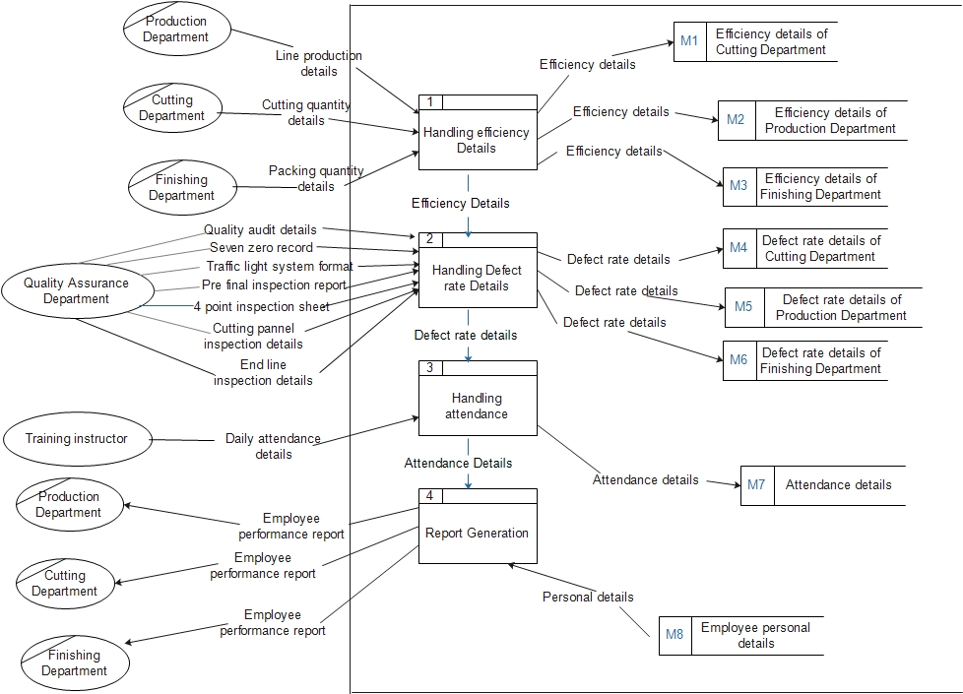Report Generation

Figure 4:Level 1 DFD for existing system

#### 2.1.1.5 Level 2 Data Flow Diagram

*2.1.1.5.1 Handling Efficiency Details*

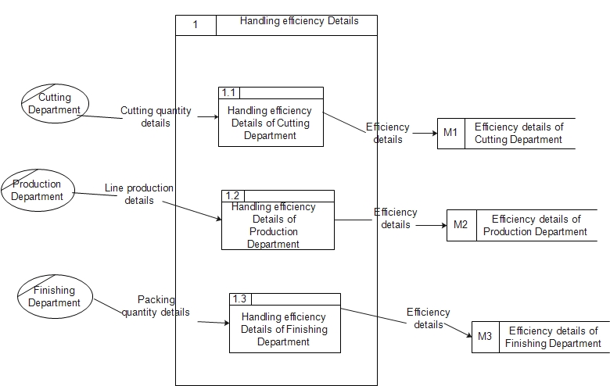

Figure 5:Level 2 DFD For existing system

*2.1.1.5.1 Handling Defect Rate Details*

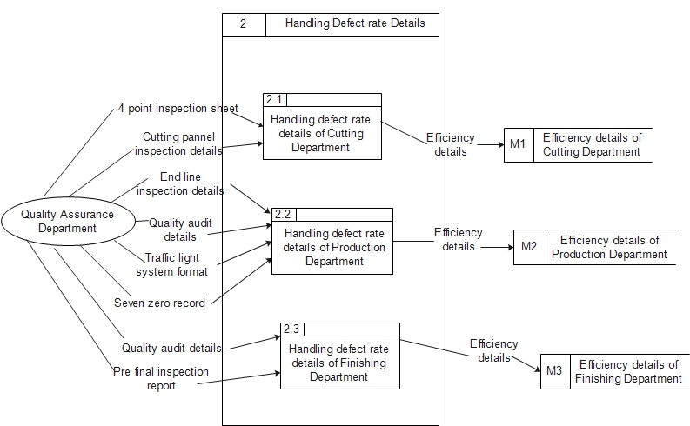

Figure 6:Level 2 DFD For existing system

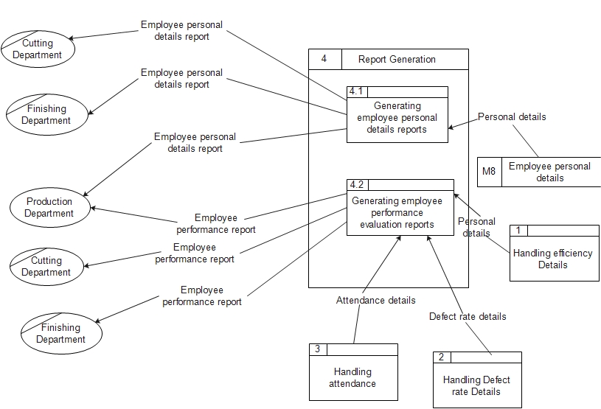

Figure 7:Level 2 DFD For existing system

### 2.1.6 Problem Definition

Currently they have a manual system. But there are many problems in the existing system.

* They have to handle many files to keep information to evaluate performance. It is difficult to handle them manually.
* There is a heavy work load.
* There is no solid and continuous report generation process for the current system.
* It is not a user friendly environment.
* It has less accuracy.
* It is time consuming.

## 2.2 Software Solutions

### 2.2.1 Requirement Catalogue

Requirements are mainly divided in to two categories as functional requirements and non-functional requirements. In the requirement catalogue these requirements are listed in two tables as shown below.

#### 2.2.1.1 Functional Requirements

Table 1: Table of Functional Requirements

|  |  |
| --- | --- |
| **ID** | **Description** |
| 01 | Should be able to keep employee personal details |
| 02 | Should be able to receive employee attendance details |
| 03 | Should be able to keep employee attendance details |
| 04 | Should be able to keep employee leave details |
| 05 | Should be able to assign absent covering workers |
| 06 | Should be able to keep employee capacity details |
| 07 | Should be able to calculate employee capacity levels |
| 08 | Should be able to keep employee quality level details |
| 09 | Should be able to calculate employee quality levels |
| 10 | Should be able to employee efficiency details |
| 11 | Should be able to calculate employee efficiency |
| 12 | Should be able to receive lost time details |
| 13 | Should be able to receive employee behavior details |
| 14 | Should be able to grade employees |
| 15 | Should be able to generate employee grading reports |
| 16 | Should be able to generate employee performance reports |
| 17 | Should be able to represent employee performance graphically |
| 18 | Should be able to evaluate performance according to job category |
| 19 | Should be able to identify training needs |
| 20 | Should be able to identify recommendations for promotions |

#### 2.2.1.2 Non-Functional Requirements

Table 2 : Table of Non - Functional Requirements

|  |  |
| --- | --- |
| **ID** | **Description** |
| 01 | Shall be able to save time |
| 02 | Shall be able to minimize paper usage |
| 03 | Shall be less costly |
| 04 | Shall be able to increase accuracy and efficiency |
| 05 | Shall be able to provide user friendly interfaces |
| 06 | Shall be able to access to the system easily |
| 07 | Shall be able to handle data files easily |
| 08 | Shall be able to run on windows XP or other windows operating systems |
| 09 | Shall be able to store and process large amount of data |
| 10 | Shall be able to secure the information |

### 2.2.2 Business System Options (BSOs)

#### 2.2.2.1 BSO 1 - Improved Manual System

One of the options for the proposed system is improvement of the manual system. Here the existing system will be revised and implemented an improved system with the changes of the procedures and standards.

#### 2.2.2.2 BSO 2 - Manual System with Simple Computer Based Systems

Another alternative solution is manual system with simple computer based system. In this case one computer would be used to store of data and to do simple calculations. One employee (computer operator) would have to handle the system. External entities would send information manually to him and the data will be updated periodically. Here a word file can be used to store data and prepare reports and an excel sheet can be used to calculate capacity levels, efficiency and etc. Then the generated reports will be send to the departments manually.

#### 2.2.2.3 BSO 3 - Computer Based Networked System

This system is capable of storing, updating and retrieving data while having less paper work. This will reduce the workload and is easy to handle. In this system everything is stored electronically and except the factory workers all other parties would have access to the database through user interfaces.

## 2.2.3 Requirement Catalogue vs. BSOs

The above mentioned functional and non-functional requirements are compared with the identified BSOs are given in the below tables.

#### 2.2.3.1 Functional Requirements vs. BSOs

Table 3 : Table of Functional Requirements vs. BSOs

|  |  |  |  |  |
| --- | --- | --- | --- | --- |
| **ID** | **Description** | **BSO 1** | **BSO 2** | **BSO 3** |
| 01 | Should be able to keep employee personal details | √ | √ | √ |
| 02 | Should be able to receive employee attendance details | √ | √ | √ |
| 03 | Should be able to keep employee attendance details | √ | √ | √ |
| 04 | Should be able to keep employee leave details | √ | √ | √ |
| 05 | Should be able to assign absent covering workers | √ | √ | √ |
| 06 | Should be able to keep employee capacity details | √ | √ | √ |
| 07 | Should be able to calculate employee capacity levels | √ | √ | √ |
| 08 | Should be able to keep employee quality level details | √ | √ | √ |
| 09 | Should be able to calculate employee quality levels | √ | √ | √ |
| 10 | Should be able to employee keep efficiency details | √ | √ | √ |
| 11 | Should be able to calculate employee efficiency | √ | √ | √ |
| 12 | Should be able to receive lost time details | √ | √ | √ |
| 13 | Should be able to receive employee behavior details |  | √ | √ |
| 14 | Should be able to grade employees | √ | √ | √ |
| 15 | Should be able to generate employee grading reports | √ | √ | √ |
| 16 | Should be able to generate employee performance reports | √ | √ | √ |
| 17 | Should be able to represent employee performance graphically | √ | √ | √ |
| 18 | Should be able to evaluate performance according to job category | √ | √ | √ |
| 19 | Should be able to identify training needs | √ | √ | √ |
| 20 | Should be able to identify recommendations for promotions | √ | √ | √ |

#### 2.2.3.2 Non Functional Requirements vs. BSOs

Table 4 : Table of Non- functional Requirements vs. BSOs

|  |  |  |  |  |
| --- | --- | --- | --- | --- |
| **ID** | **Description** | **BSO 1** | **BSO 2** | **BSO 3** |
| 01 | Should be able to save time | √ | √ | √ |
| 02 | Should be able to access to the system easily |  | √ | √ |
| 03 | Should be able to handle data files easily |  |  | √ |
| 04 | Should be able to increase accuracy and efficiency |  |  | √ |
| 05 | Should be able to provide user friendly interfaces |  | √ | √ |
| 06 | Should be able to access system resources concurrently |  |  | √ |
| 07 | Should be able to secure the information |  | √ | √ |
| 08 | Should be able to run on windows XP or other windows operating systems |  | √ | √ |
| 09 | Should be able to store and process large amount of data |  |  | √ |
| 10 | Should be able to minimize paper usage |  |  | √ |

### 2.2.4 The Selected BSO and Justification

According to the above mentioned requirement fulfilment the Business System Option of Using Computer Based Networked System would be the best option since it fulfills all the functional and non-functional requirements. Furthermore it is technically, operationally and economically feasible.

The first BSO needs a lot of work force and a lot of paper work. Also it is not easy to handle such kind of a system manually. It is time consuming too. Furthermore we cannot be sure about the accuracy of this option. When compared with other two options this is less productive. Therefore this is not acceptable.

The second BSO would not facilitate the objectives such as consumption of fewer resources, reduce documentation and improve efficiency. The reports need to be manually processed and it would be an unsuitable, half-fulfilled mission acquisition. Therefore this is not acceptable.

In the third BSO the system provides storage, updating and retrieving facility. In this system everything is stored electronically. Therefore very less amount of paper work is required and information can be retrieved very easily without searching here and there into document files. With the deployment of this system all important reports can be generated automatically with no necessity for expensive manual commitments and the performance can be evaluated accurately. Therefore this is an acceptable option.

Therefore the best option would be introducing a computerized system replacing the existing one.

# 3. SYSTEM DESIGN

## 3.1 Natural Language Description with Semi Formal Graphical Software Process Models

3.1.2 Context Diagram

Figure 8:Context diagram for proposed system

### 3.1.2 Document Flow Diagram



Figure 9: Document Flow diagram for proposed system

### C:\Users\dcb\Desktop\nw.jpg3.1.3 Level 1 Data Flow Diagram

Figure 10:Level 1 DFD for proposed system

### 3.1.4 Level 2 Data Flow Diagram

#### 3.1.4.1 Handling Efficiency Details

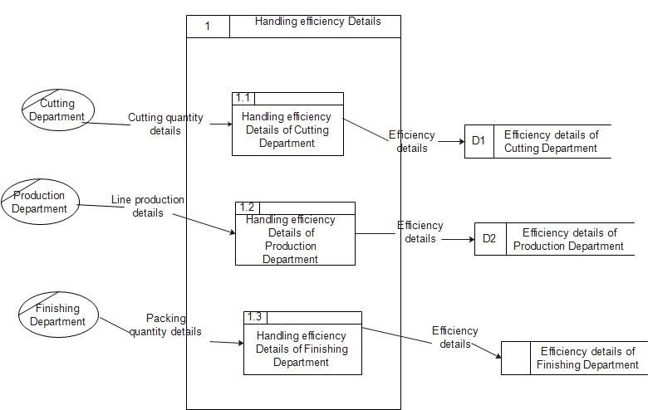

Figure 11:Level 2 DFD

3.1.4.2 Handling Defect Rate Details

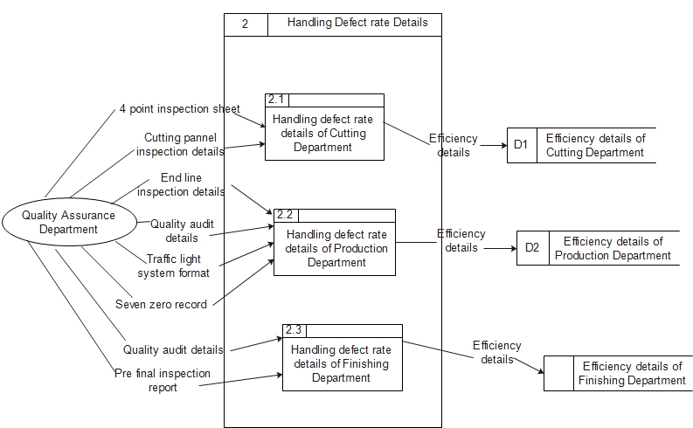

Figure 12:Level 2 DFD

#### 3.1.4.3 Report Generation process



Figure 13:Level 2 DFD

## 3.2 Architectural Design

Computer architecture in computer engineering is the science and art of selecting and interconnecting hardware components to create computers that meet functional, performance and goals. The architectural layer generally encapsulates a software application's technical complexities independent of the business logic, thereby providing a tally between the business functionality and the underlying technical infrastructure. Layered architectures contribute to the high availability of software infrastructures by enabling components to detect failure of components in adjacent layers. One of the key properties of a layered architecture is that the higher layer has knowledge of the lower layer, while the lower layer must not make any assumptions on the higher layers. In a multi-layered architecture, it is valid for a layer to skip lower other layers but it still must not have dependencies on higher layers. When considering the system components of the system, the following layers and the dependencies between those layers could be identified as follows.

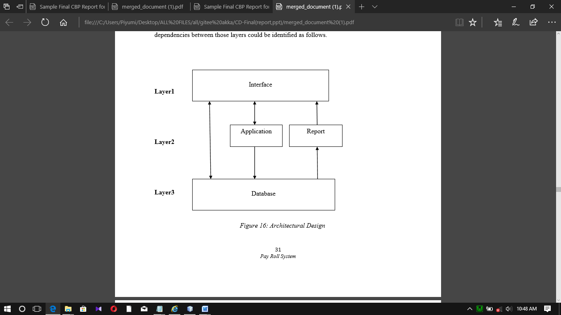

Figure 14: Architectural Design

## 3.3 Data Base Design

### 3.3.1 Entity Model

This shows the relationship in-between entities.



### 3.3.2 Logical Data Structure

Basically employee has logical relationship with HR Department and others



### 3.3.3 Entity Relationship Diagram

In entity-relationship diagram, entities are shown as points, polygons, circles, or ovals. Relationships are shown as lines connecting the points, polygons, circles, or ovals. ER diagram has an equivalent relational table, and any relational table has an equivalent ER diagram. ER diagramming is an important to engineers in the design, optimization. ER diagram for the system is as follows.

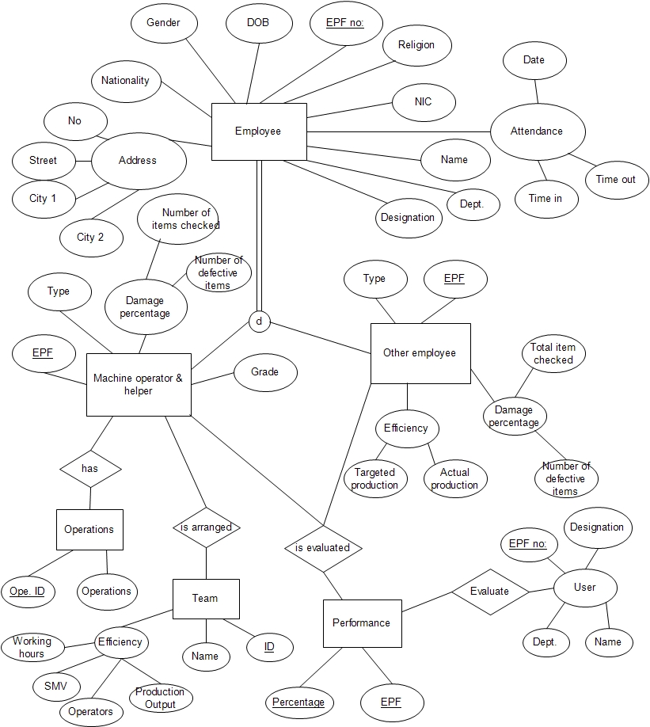

Figure 15:ER Diagram

### 3.3.4 Relational Schema

The relationships of above mentioned tables are shown under the Enhanced Entity Relationship diagram.

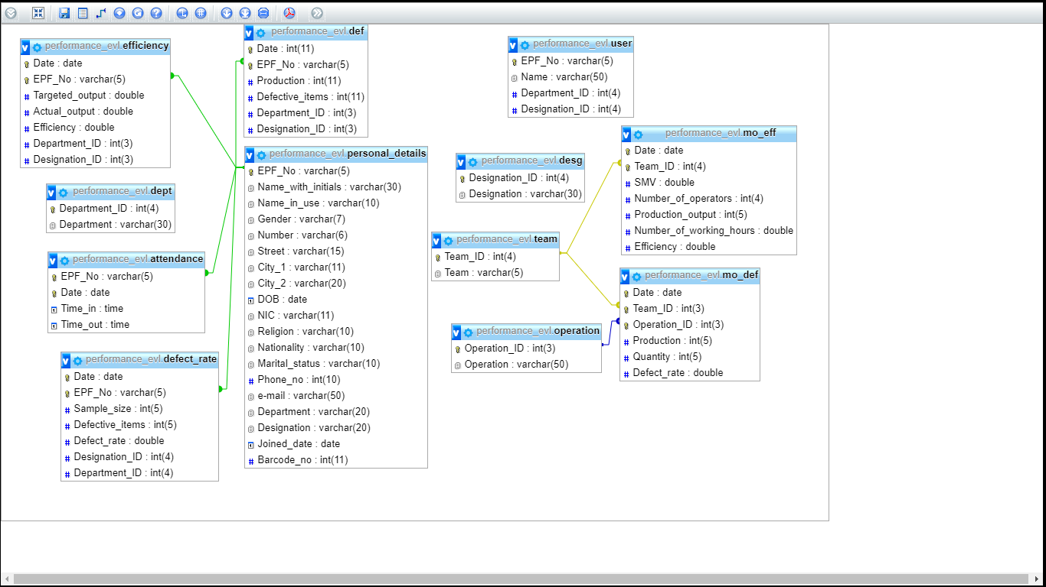

Figure 16:Relational Schema

## 3.4 Graphical User Interface Design

The process of designing interfaces is a user focused activity. This means a prototype methodology of interactively collecting information, constructing a prototype, assessing usability, and making refinements.

### 3.4.1 Login

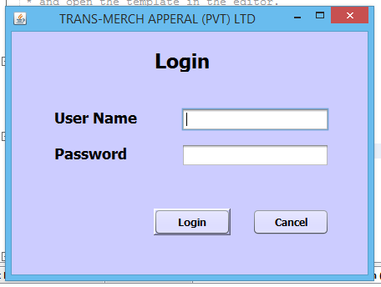This interface is used to allow different types of authorized users to log into the system. After adding their user name and password to relevant fields users can log into the system.

Figure 17:Log in

### 3.4.2 Main Menu

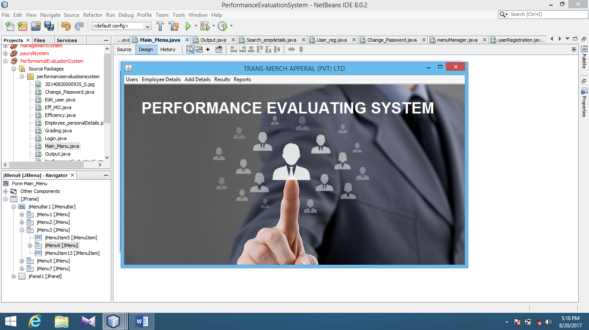This is the key interface of the system which guides the user to perform any functionality in the system.

Figure 18:Main Menu

### 3.4.3 User Registration

This menu is used for registering new users according to their designation.

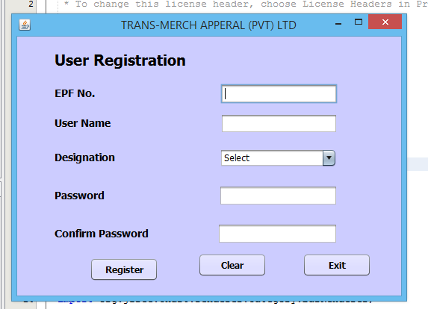

Figure 19:User Registration

### 3.4.4 Edit Users

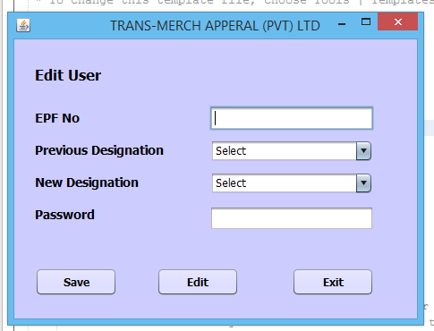When the current employees get promoted or demoted their designations are needed to be changed since only a limited number of designations have the access to the system. This interface is used for that purpose

Figure 20:Edit User

### 3.4.5 Change password

Current users of the system can change their passwords whenever needed by using this interface.

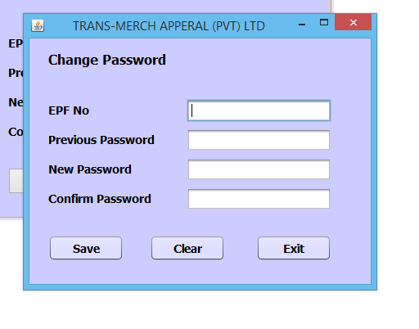

Figure 21:Change Password

### 3.4.6 Add Details

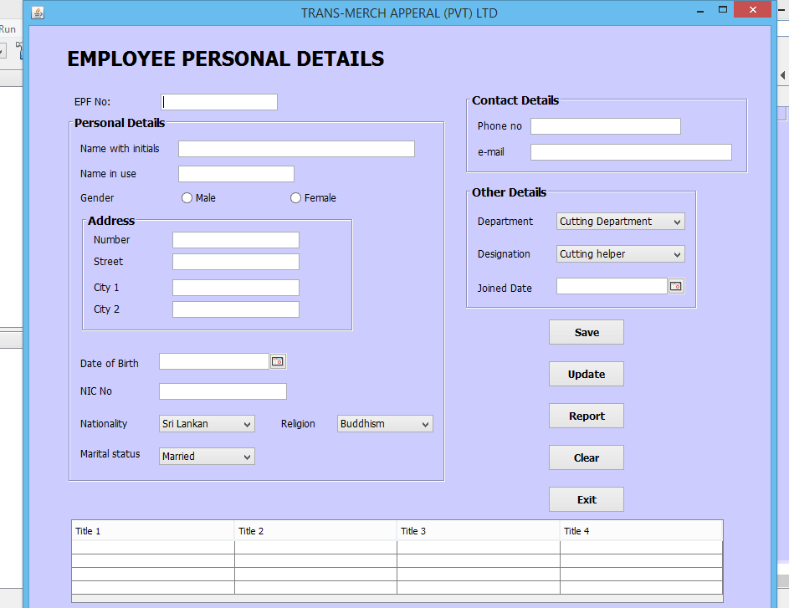This interface is used to add employee personal details.

Figure 22:add Personal Details

Figure 23: Add Details

### 3.4.7 Search Details

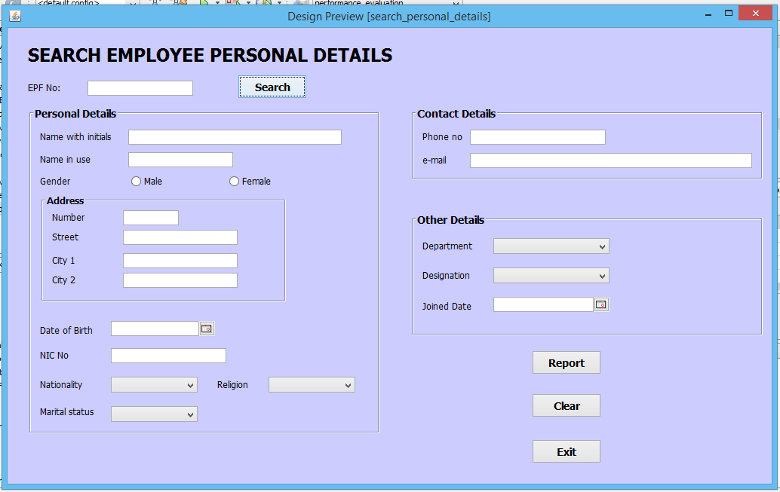This interface is used for searching employee details by providing their EPF number.

Figure 24:Search personal details

### 3.4.8 Efficiency

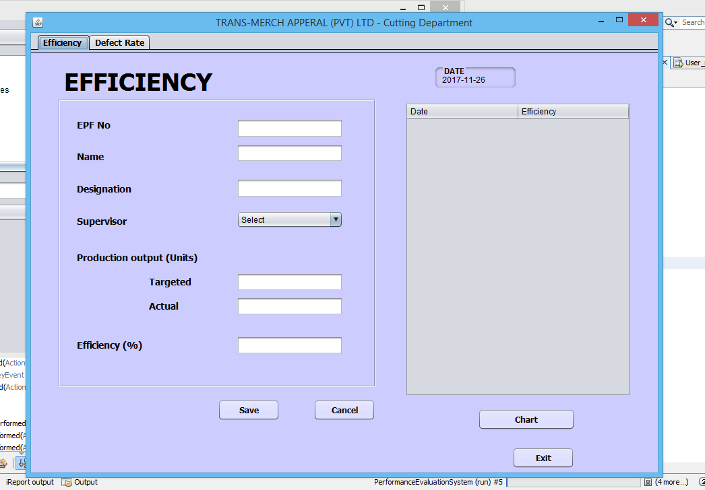This interface is used for recording the details relevant for the efficiency of the workers of the Cutting Department.

Figure 25:Efficiency

### 3.4.9 Defect Rate

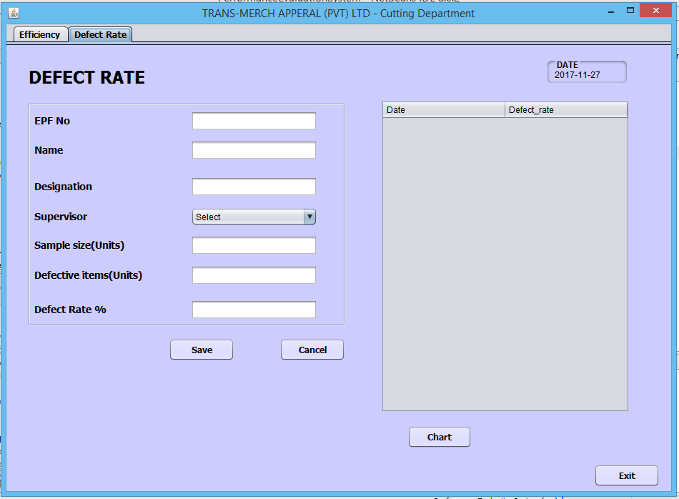This interface is used for recording the details relevant for the efficiency of the workers of the Cutting Department.

Figure 26:Defect Rate

### 3.4.10 Efficiency

This interface is used for recording the details relevant for the efficiency of the workers of the Production Department. Since there is a large number of machine operators and helpers their efficiency is calculated according to their team.

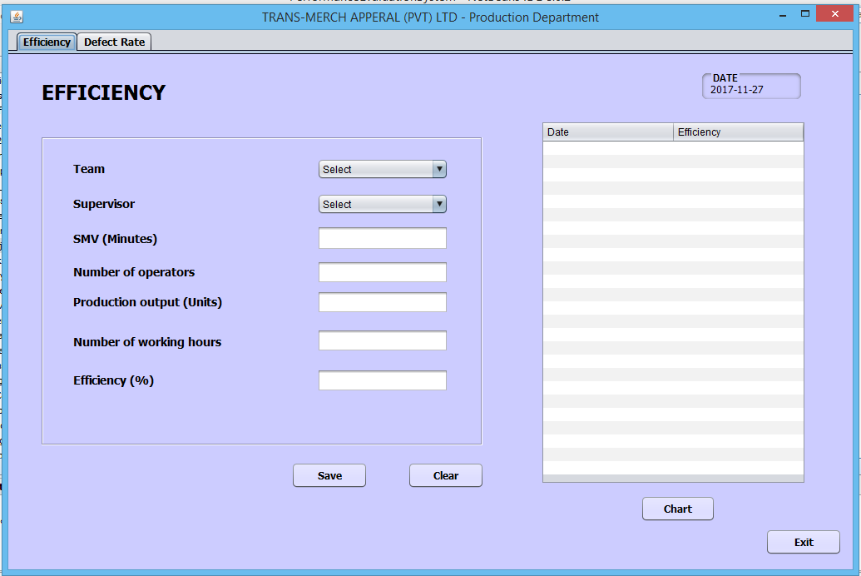

Figure 27:Efficiency

### 3.4.11 Defect Rate

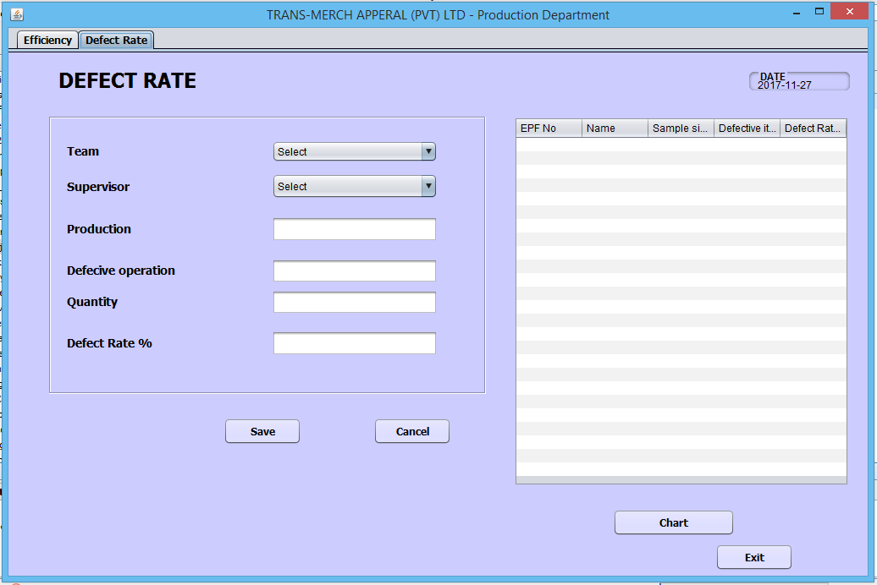This interface is used for recording the details relevant for the defect rate of the workers of the Production Department. It is useful for determining the quality of their work

Figure 28:Defect Rate

### 3.4.12 Set Teams

This interface is used for uploading the information about the teams which are arranged by the Planning Department according to their capabilities.

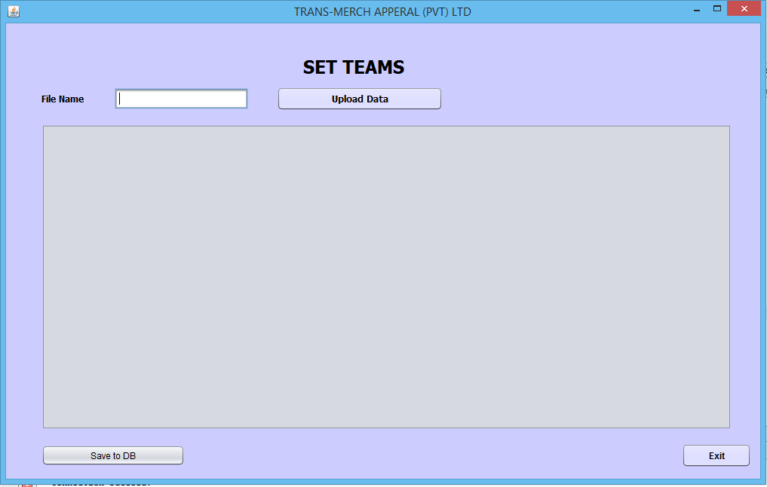

Figure 29:Set teams

### 3.4.13 Attendance

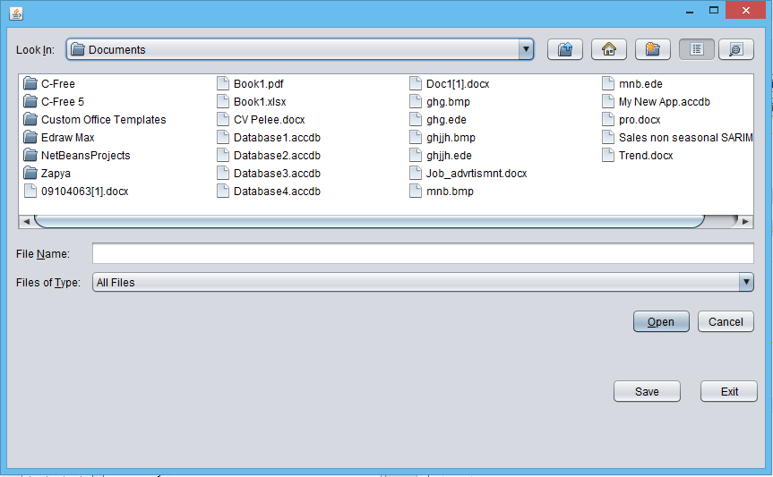This interface is used for saving the details relevant for the attendance of the workers of the Cutting Department.

Figure 30:Attendance

### 3.4.14 Set Holidays

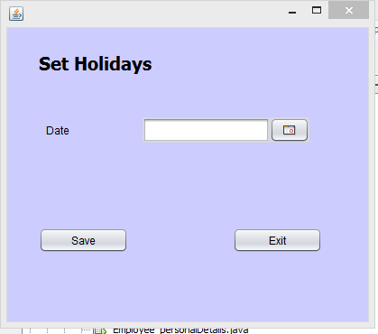This menu is used for selecting the holidays.

Figure 31:Set Holidays

### 3.4.15 Best Employee

This menu is used for selecting the best employee within a certain period according to their department.

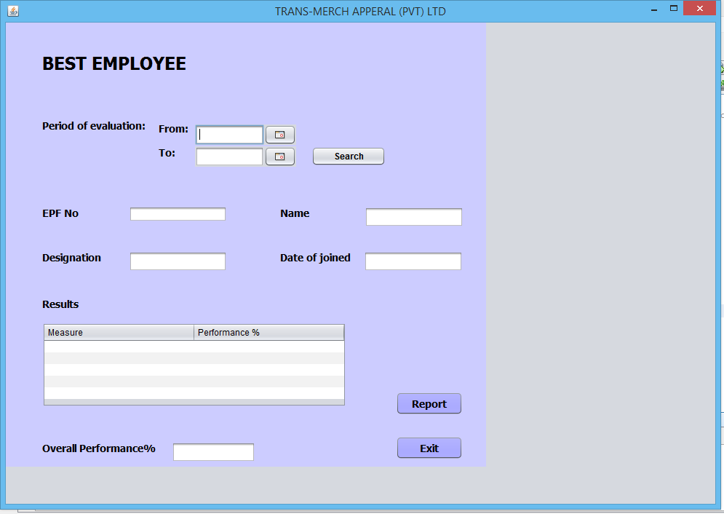

Figure 32:Best Employee

### 3.4.16 Overall Performance

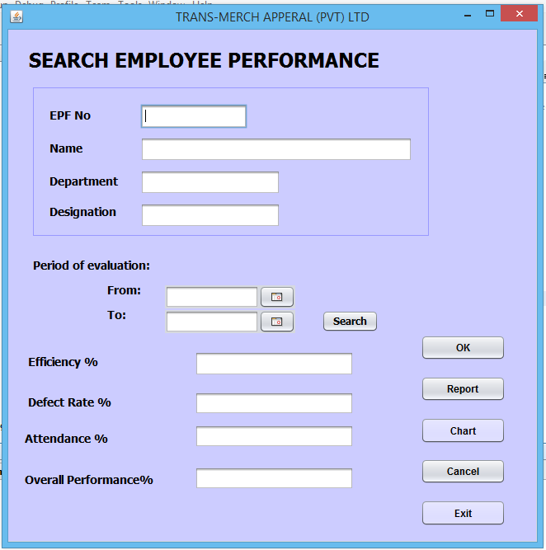This interface is used for evaluating the overall performance of an employee.

Figure 33:Search Performance

## 3.5 Report Design

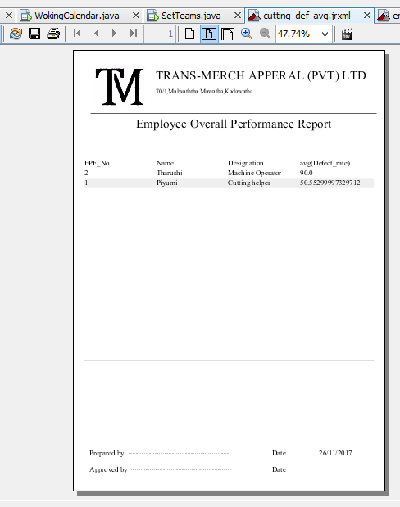Reports are generated annually, monthly and graphically. Followings are some reports which are generated through the system.

Figure 34:Overall Performance Report

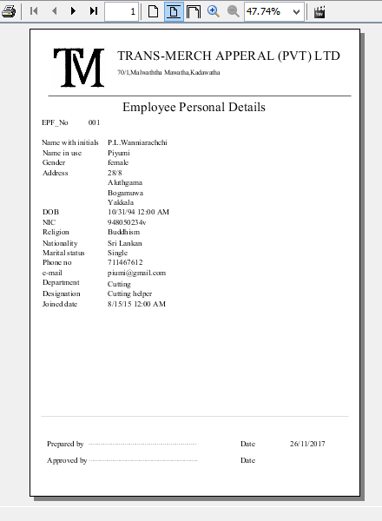

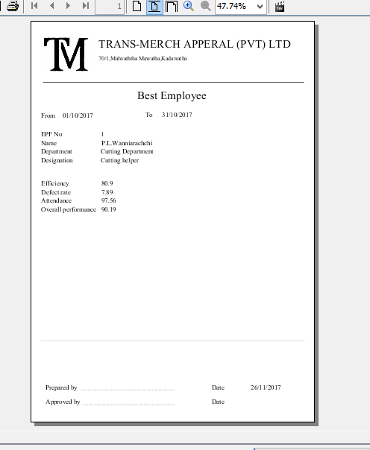

Figure 35:Best Employee Report

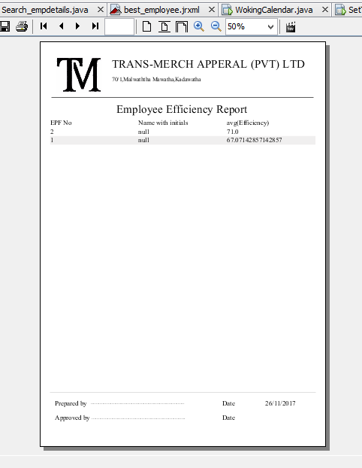

Figure 36:Employee Efficiency Report

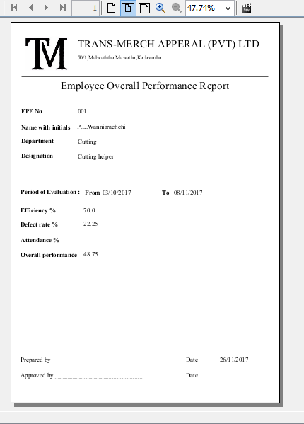

Figure 37:Employee Overall performance report

# 4.IMPLEMENTATION

## 4.1 Data Structures

A data structure in computer science is a way of storing data in a computer so that it can be used efficiently. Often a carefully chosen data structure will allow the most efficient algorithm to be used. The choice of the data structure often begins from the choice of an abstract data type. A well-designed data structure allows a variety of critical operations to be performed, using as few resources, both execution time and memory space, as possible. Data structures are implemented by a programming language as data types and the references and operations they provide. Under the data structures, mainly consider about the data arrays. Here for create image array. Data structures are not broadly used for the system.

## 4.2 Algorithms Used

## 4.2.1Calculating Efficiency

int targeted=Integer.parseInt(target.getText());

int act= Integer.parseInt(actual.getText());

double effi=((act)*100/targeted);

efficiency.setText(" "+effi);

## 4.2.2 Calculating Defect Rate

int samp=Integer.parseInt(def_sample.getText());

int def= Integer.parseInt(items.getText());

double drate=((samp-def)*100/samp);

rate.setText(" "+drate);

## 4.2.3 Calculating Attendance

try{

BufferedReader br=new BufferedReader(new FileReader(filename));

String line;

while((line=br.readLine())!=null){

String []value=line.split((","));

String sql="Insert into attendance(date,epf_no,time_in,time_out) values('"+value[0]+"','"+value[1]+"','"+value[2]+"','"+value[3]+"')";

pst=conn.prepareStatement(sql);

pst.executeUpdate();

}

br.close();

}catch(Exception e){

JOptionPane.showMessageDialog(null, e);

}

try{

BufferedReader br=new BufferedReader(new FileReader(filename));

String line;

while((line=br.readLine())!=null){

String []value=line.split((","));

String sql="Insert into attendance(date,epf_no,time_in,time_out) values('"+value[0]+"','"+value[1]+"','"+value[2]+"','"+value[3]+"')";

pst=conn.prepareStatement(sql);

pst.executeUpdate();

}

br.close();

}catch(Exception e){

JOptionPane.showMessageDialog(null, e);

}

## 4.2.5.Calculating Overall Performance

SimpleDateFormat format=new SimpleDateFormat("yyyy-MM-dd");

String datee1=format.format(date1.getDate());

String datee2=format.format(date2.getDate());

String EPF =epf.getText();

try{

final LocalDate start=date1.getDate().toInstant().atZone(ZoneId.systemDefault()).toLocalDate();

final LocalDate end=date2.getDate().toInstant().atZone(ZoneId.systemDefault()).toLocalDate();

long weekdays=calcWeekDays( start, end);

// int wee=toIntExact(weekdays);

System.out.println("wee "+weekdays);

// System.out.println(""+wee);

String sql="SELECT COUNT(*) FROM `attendance` where EPF_No='"+EPF+"' and date between '"+datee1+"' and '"+datee2+"' ";

pst=conn.prepareStatement(sql);

rs=pst.executeQuery();

if(rs.next()){

float no_of_att=rs.getFloat("COUNT(*)");

// float n=Double.parseFloat(no_of_att);

float avg_att=(no_of_att/(float)weekdays);

String avatt=df.format(avg_att);

attendance.setText(""+avatt);

}

}catch(Exception e){

JOptionPane.showMessageDialog(null,e);

}

try{

String ql="Select avg(Efficiency) from cutting_efficiency where date between '"+datee1+"' and '" +datee2+"' and (EPF_No)='"+EPF+"'";

pst=conn.prepareStatement(ql);

rs=pst.executeQuery();

if(rs.next()){

Double effi=rs.getDouble("avg(Efficiency)");

efficien.setText(df.format(effi)+"");

}

}catch(Exception e){

JOptionPane.showMessageDialog(null,e);

}

try{

String ql="Select avg(Defect_rate) from cutting_defect_rate where date between '"+datee1+"' and '" +datee2+"' and (EPF_No)='"+EPF+"'";

pst=conn.prepareStatement(ql);

rs=pst.executeQuery();

if(rs.next()){

Double effi=rs.getDouble("avg(Defect_rate)");

def.setText(df.format(effi)+"");

}

}catch(Exception e){

JOptionPane.showMessageDialog(null,e);

}

try{

double x=Double.parseDouble(efficien.getText());

double y= Double.parseDouble(def.getText());;

double z=(x+(1-y));

overall.setText(df.format(z)+"");

}catch(Exception e){

JOptionPane.showMessageDialog(null,e);

}

### 4.2.5 Generate Reports

This algorithm is used to generate reports.

try {

String reportName="C:\\Users\\dcb\\Desktop\\IMGT 3+34\\PerformanceEvaluationSystem\\src\\report\\cutting_eff_avg"; //set the jrxml file path

JOptionPane.showMessageDialog(null,"Please wait");

Map<String, Object> para = new HashMap<String, Object>();

JasperCompileManager.compileReport(reportName+".jrxml"); //compile the jrxml file

FileOutputStream files= new FileOutputStream(reportName+".pdf"); //convert the jrxml file to pdf

JasperPrint print=JasperFillManager.fillReport(reportName+".jasper", para,conn);

JRExporter exporter=new JRPdfExporter();

exporter.setParameter(JRExporterParameter.JASPER_PRINT, print);

exporter.setParameter(JRExporterParameter.OUTPUT_STREAM,files);

exporter.exportReport(); //export the report

JOptionPane.showMessageDialog(null,"Report file Saved Successfuly");

files.close();//close the covert pdf file

File f=new File("C:\\Users\\dcb\\Desktop\\IMGT 3+34\\PerformanceEvaluationSystem\\src\\report\\cutting_eff_avg.pdf"); //set the pdf file location

Desktop.getDesktop().open(f); //open the relavent file

} catch (IOException ex) {

Logger.getLogger(NewJFrame.class.getName()).log(Level.SEVERE, null, ex);

} catch (JRException ex) {

Logger.getLogger(NewJFrame.class.getName()).log(Level.SEVERE, null, ex);

} catch (Exception ex) {

Logger.getLogger(NewJFrame.class.getName()).log(Level.SEVERE, null, ex);

}

# 5. TESTING

## 5.1 Testing Methodology Used

In the testing chapter it has checked whether the system is working according to the requirements.

It is system designer’s duty to supply ‘error-free’ software to the client. Hence before installing it in the client’s site it should be tested. Software testing is an empirical investigation conducted to provide stakeholders with information about the quality of the product or service under test, with respect to the context in which it is intended to operate. This includes, but is not limited to, the process of executing a program or application with the intent of finding software bugs.

There are various types of testing methodologies used at present. They are

* White Box testing
* Black Box testing
* Gray Box testing
* Unit testing
* System testing
* Integration testing

Here, the White Box testing and Black Box testing method was used as the testing method. The white box testing method was used as the primary testing method. Then the Black Box testing method was used. The results of the Black Box test are shown below.

## 5.2 Test Reports

This chapter will focus on verification of system data by testing. Testing is any activity aimed at evaluating an attribute or capability of a program or system and determining that it meets its required results. Although crucial to software quality and widely deployed by programmers and testers, software testing still remains an art, due to limited understanding of the principles of software The purpose of testing can be quality assurance, verification and validation, or reliability estimation. Testing can be used as a generic metric as well.

### C:\Users\dcb\Desktop\DB\m1.PNG5.5.1 Log in

Figure 38: Message for wrong user name or password

### 5.5.2 Validation Errors

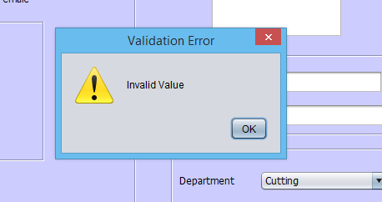

Figure 39:Message for Validation Errors

### 5.5.3 Messages for Report Generation

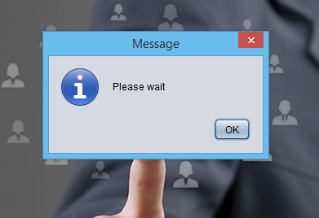

Figure 40:Message for Report Generation

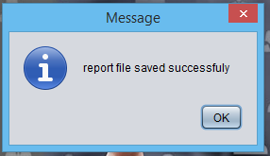

Figure 41: Message for Report Generation

## 5.3 User Evaluation

### 5.3.1 Speed

Speed of work has increased dramatically because of the system. Adding employees, salary calculation and updating records are faster in this system.

### 5.3.2 Reduced Errors

The system was designed with the intention of avoiding mistakes as much as possible. The fields are validated so it would give error messages once wrong data are added.

### 5.3.3 User Friendliness

The system is very user friendly. The system has been built in such a way so that the employees can easily understand the computerized system and work comfortably. The system is not complex.

### 5.3.4 Help to Make Management Decisions

The data base is designed to facilitate management decision making process. Management can take reports which analyses the performance of the company easily

# 6 . DISCUSSION AND CONCLUSION

## 6.1 Summery

At the present the organization uses manual payroll system. There are some problems and weaknesses of the existing performance evaluationsystem of Trans-Merch Apperal (PVT) Ltd. The aim of this project is to create a sophisticated system which will reduce the inconveniences facing currently and make the process smooth by developing a system with improved performance security and reliability.

There are various functional and non-functional requirements expected by the organization from this new computerized system. It can be identified three B.S.O.s which are satisfying most of those functional and non-functional requirements. By checking the financial, technology, organizational and the operational feasibility of each B.S.O, B.S.O 2 was selected to build.

By developing the semi-formal graphical software model for the proposed system the final database graphical user interfaces were designed for the new system and also designed the reports which are needed to create by this system. These reports are used by the management.

When implementing the system data structures were not used within this. Some algorithms used for saving, loading data, loading data from table to a combo box, loading data to text box when index change in a combo box, automatically loading the employee number, adding entered data to the list view. The implementation can be done in an improved further.

## 6.2 Limitation of this System

There were some limitations that had to face during this study which were not expected at the beginning of this project.

First it was difficult to find out an organization for building a computerized system. Most of the organizations did not like to reveal their internal information to an undergraduate who is outside the organization. And it was difficult to gather information needed to analyze the existing system with the dynamic style of the organization.

The available technology within the organization restricted the system by adding sophisticated features into it.

The time availability for the project was very limited and sometimes failed to follow the time schedule which was prepared at the beginning of the system. Lack of knowledge about the MySql and the object oriented programming language used was a problem. Hence couldn’t use more efficient designs of interfaces and efficient coding. So faced time related problems because it took time to coding.

## 6.3 Discussion and Recommendation for Further Works

Though there were some mistakes in the developed system a great effort has taken to minimize those errors.

There were two supervisors to coordinate this project. Once a week, a discussion with those supervisors was held on the works carried out through that week. According to the feedback given by each supervisor the modifications were done to the system. Hence the most of the errors could be eliminated.

There was a limited time duration for the works because of the unexpected barriers occurred from the outside environment. Hence the commitment towards building of this project was increased in order to follow the planned time schedule as much as possible.

Lack of knowledge about the data base designing and programming language was a big barrier. That could be overcome by referring into many books and web sites to gather knowledge about the structured system analysis and design methodologies, SSADM select case tools, data base designing, MySql server and Java programming language. And ask for help from the peers who are having that knowledge.

But still there are some mistakes in the system that can be avoided by further works. Those are further analysis about the existing system, design of the interfaces of the system.

## 6.4 Conclusion

This is a result of a course module in third academic year of the degree program. But the knowledge gathered up to that level was highly contributed to the success of this project.

The knowledge gathered under Structured System Analysis and Management Information System was very useful in analyzing the organization’s existing system. The whole analysis was based on that knowledge.

The topics studied under Human Resource Management such as types of employees, selection process, EPF/ETF calculation etc. Involving in this kind of a project may very helpful in future career developments in the dynamic industrial environment as an industrial management graduate.

It could identify the functions of a Management Information System through handling this project. This will be use full in future because all the leading firms are now using sophisticated technologies. Hence the practice to operate a computer based system will be useful for an industrial management graduate.

It is a duty of an industrial management graduate to solve the problem in the real industrial situations. The practice gathered through this project as analyzing a problem, finding alternative solutions, selecting a best solution by considering internal and external environmental factors will be useful in future to take efficient decisions for any situation.

Not only that successfully implementing of any decision is another practice that gained through this project as preparing a payroll system by identifying each activity of a big project, to strategically change it when unexpected barriers coming from the external society and to handle limited recourses to successfully achieve the goals.

This course module provided us a greater exposure towards the practical application of the theoretical knowledge. This was more meaningful than only learning theory. It gave us firsthand experience on how the industry really works.

This course module also helped us develop our personal skills like presentation skills and self-confidence.

**REFERENCES**

1. http://social.msdn.microsoft.com/Forums/en-US/categories)
2. en.wikipedia.org/wiki/Visual_Basic_.NET
3. www.Kuppiya.com
4. SQL forums
5. http://vb.net-informations.com/collections/vb.net_collections_tutorials.htm
6. http://developer.postgresql.org/pgdocs/postgres/sql-altertsconfig.html
7. http://[www.developerfusion.com/tag/vb.net/](http://www.developerfusion.com/tag/vb.net/)
8. http://www.codeguru.com/